Git Commands
git init : initialize the new git repo in current directory
the directory will available in hidden files
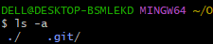

git clone (repo url): This command clone the repository from central repo to local machine.
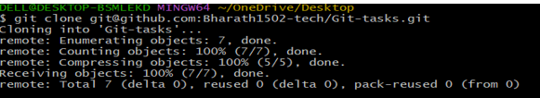

git status: shows the modified files which are in un-tracked
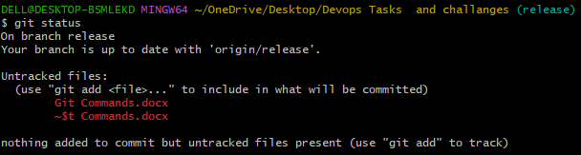

git add: move the untracked file or tracked area for commit.
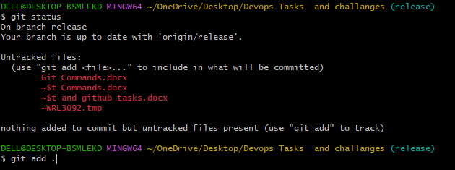
git commit -m “message”: commit the modified files or added files to tracking area. Add a commit message.
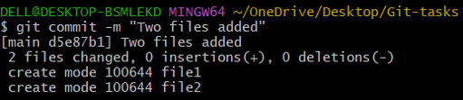

git push: pushes committed changes to central repository.
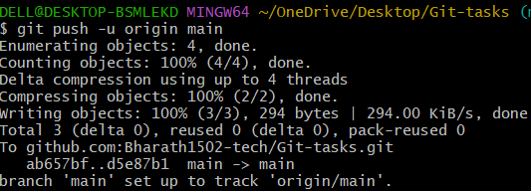

git pull: merge modified files to local repo from central repo.

git fetch: Download files and modified changes from remote to local repo.

git merge (branch name): merge modified files from other branch to current branch.

git log: shows the commit history of recently modified files.
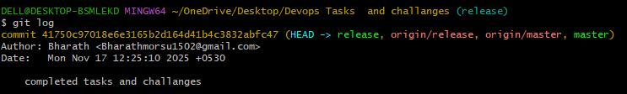

git diff: shows the difference between working directory and staged changes.
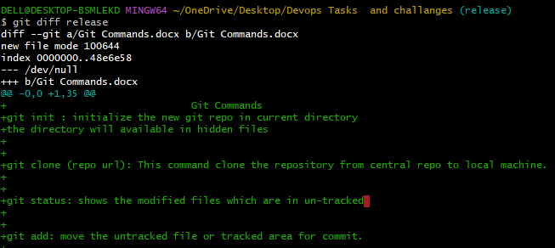

git branch: lists the branches available in a server.
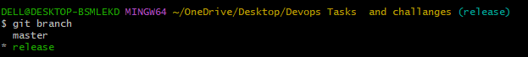

git branch (branch name): creates a new branch
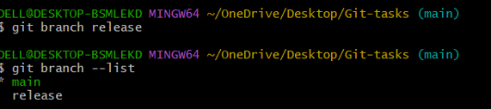
git checkout (branch name): switches the branch from working branch to other branch.
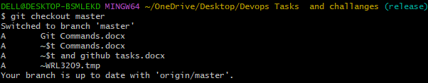

git checkout -b (branch name): Creates a new branch and changes to newly created branch.

git merge (branch name): merge changes from given branch to current branch.
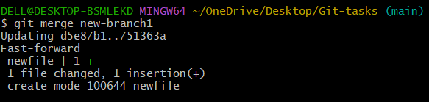

git rebase (branch name): applies changes from one branch to another branch.

